For all the below exercises submit document with clear cut snapshots of steps that you have taken to arrive at solution.

1. Reading from different datasources

a) read data from web and show any one of the table data in table visualization

<https://en.wikipedia.org/wiki/Rahul_Dravid>

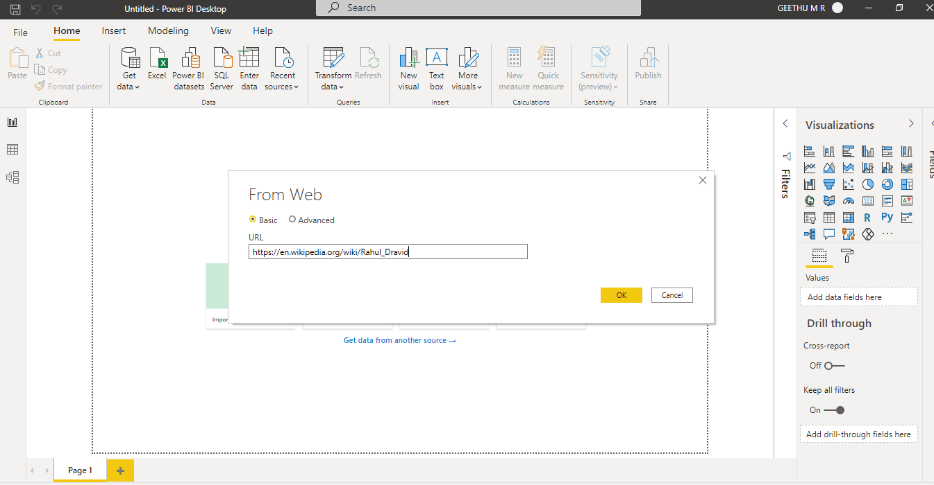

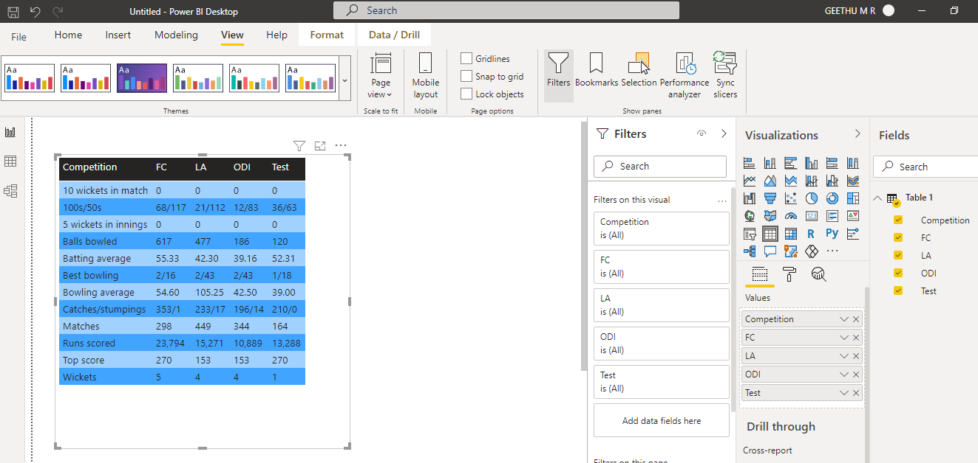

b) Create an xml file by yourself and read data from XML file into power bi

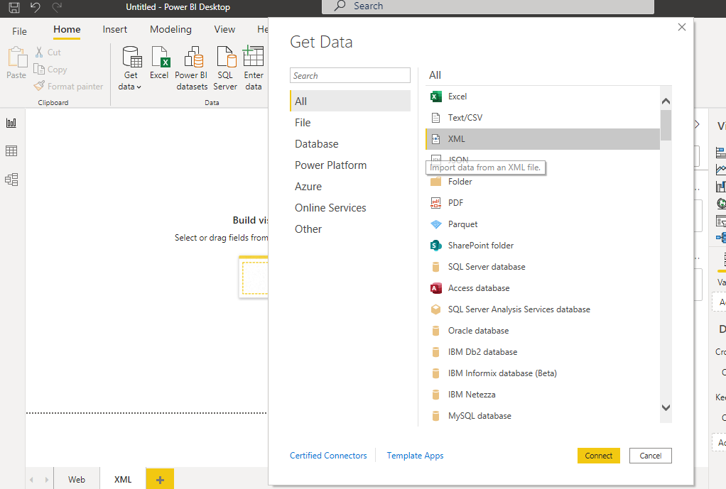

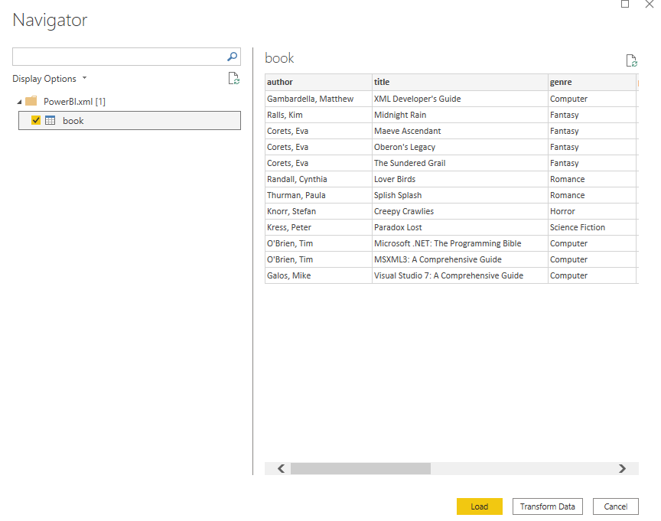

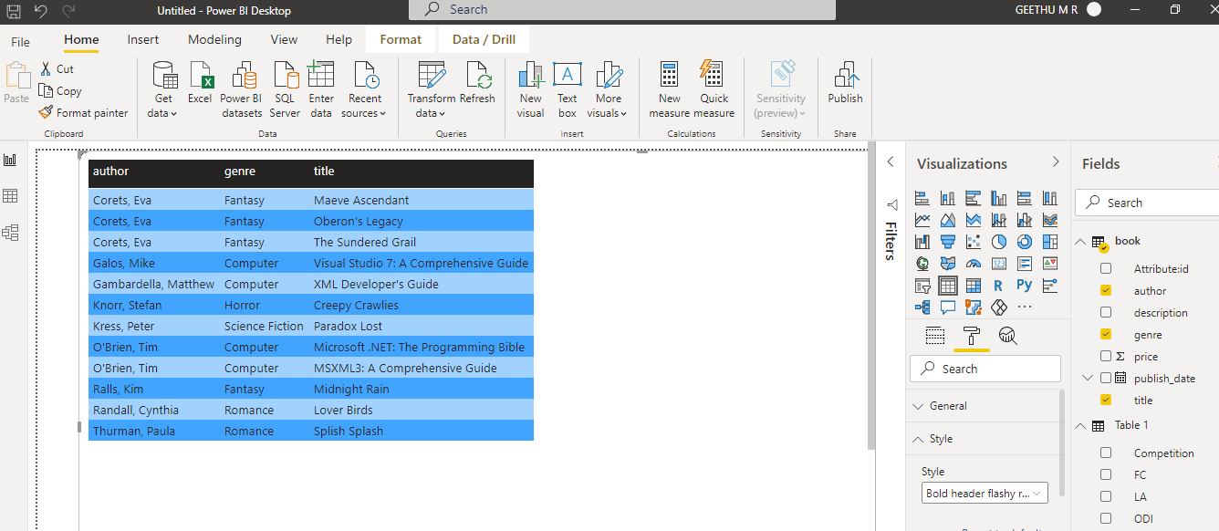

2.Transformations in Query Window

a.Emp.txt file has below data:

eno,ename,sal

1,haria,$5000

2,sasi,$6000

Remove $ from sal and show in Table visualization

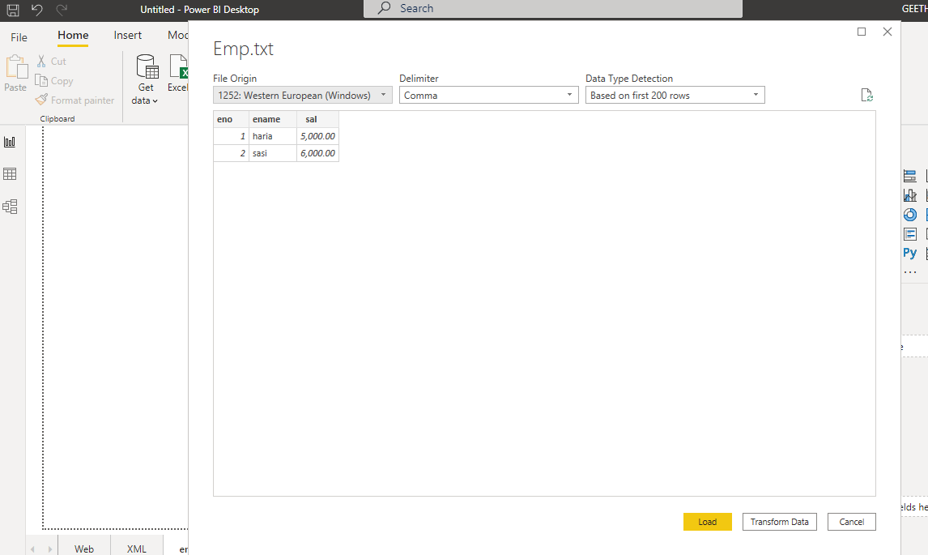

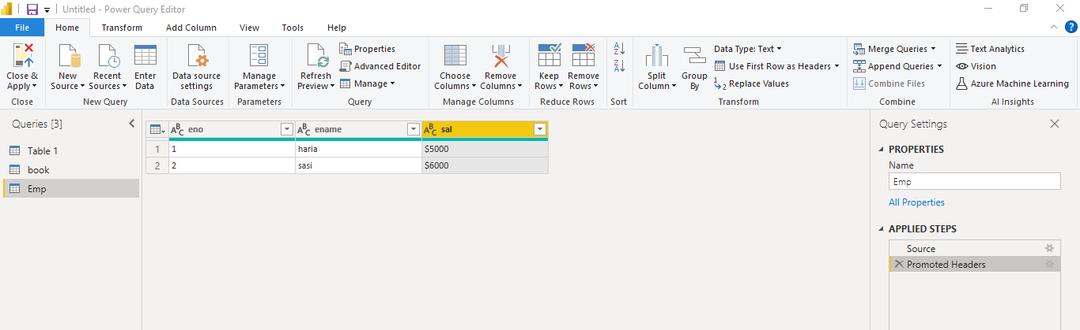

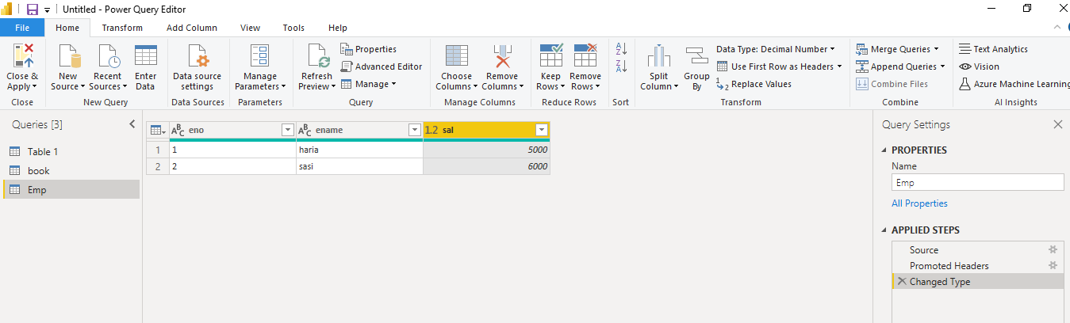

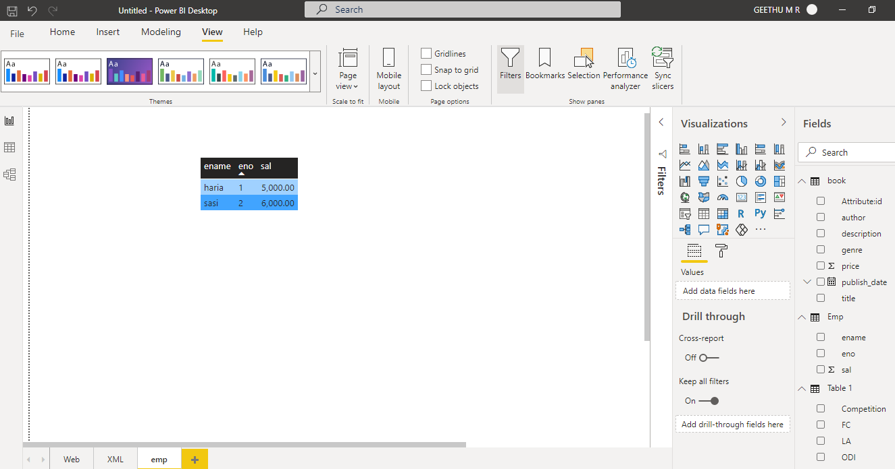

b. Department.txt has below data

dno,dname,loc

10,maths,hyd

20,science,che

Departmenthistory.txt has below data

dno,dname,loc

30,History,mumbai

40,Commerce,Delhi

Read data from above files and using append queries combine data from both and show in Table visualization

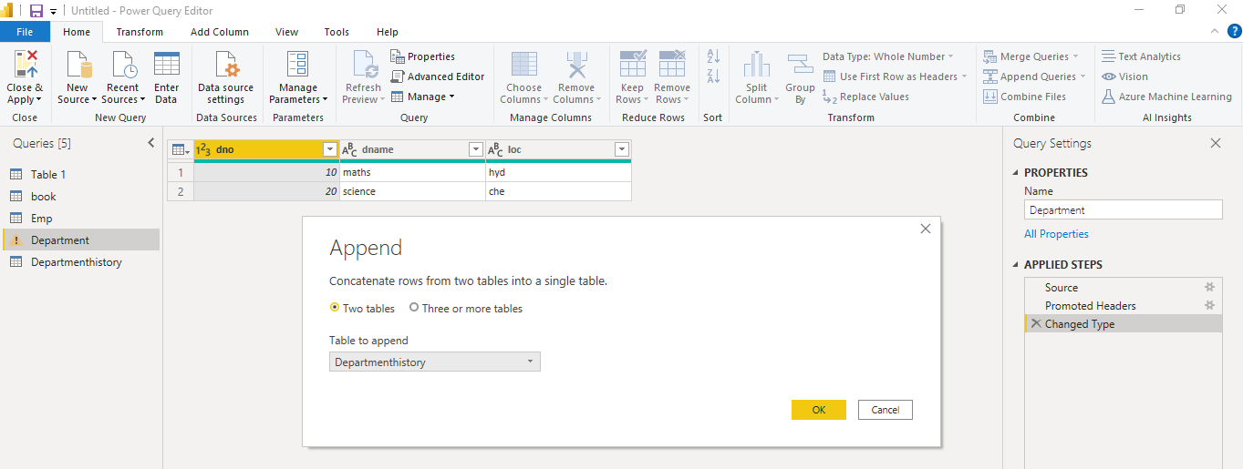

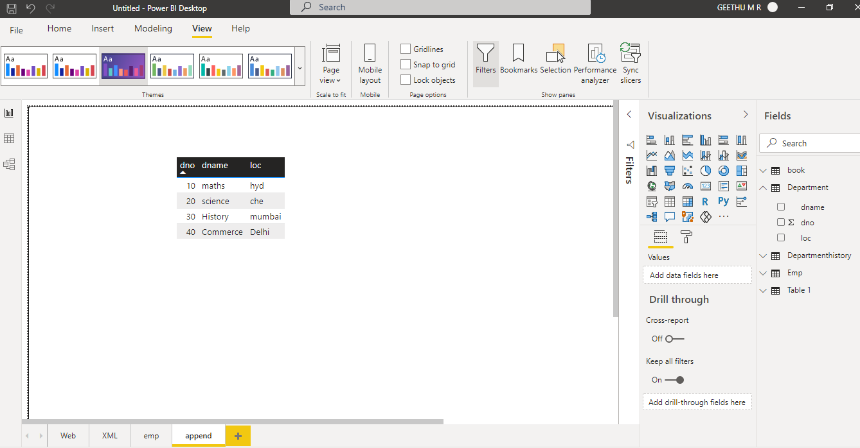

c. Read data from deparment.txt and remove loc colum in query and remove other columns other than loc column

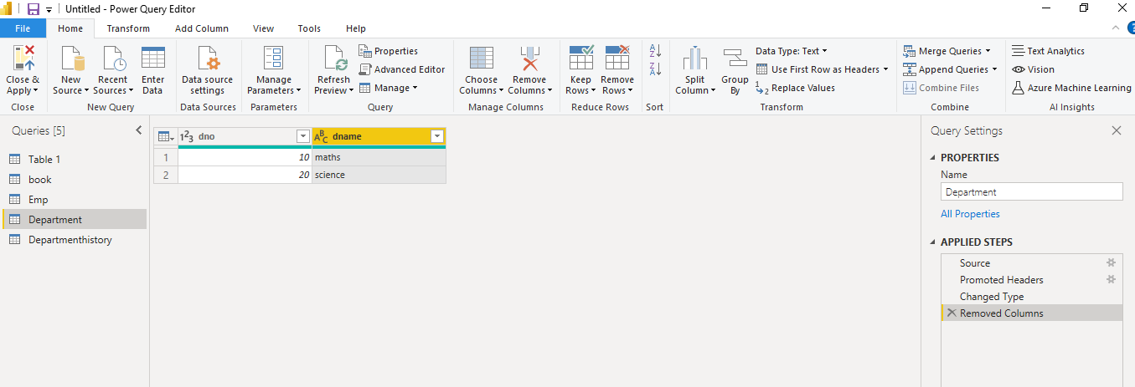

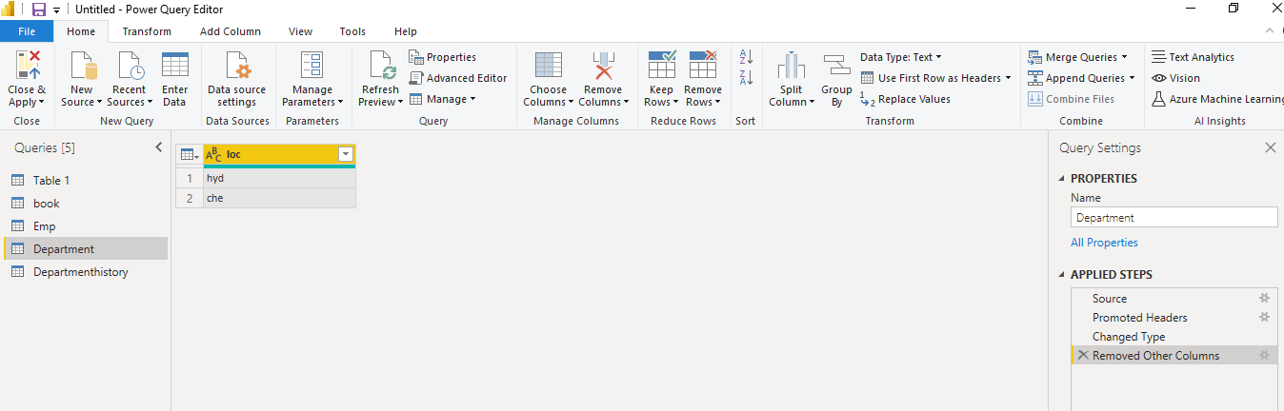

d. create table manually in query window with following data

colorid,colorname

1,Red

2,Blue

3,Green

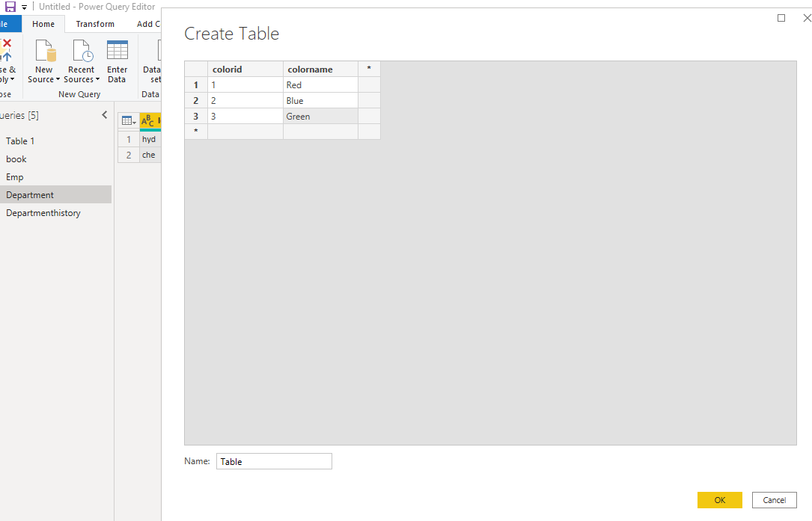

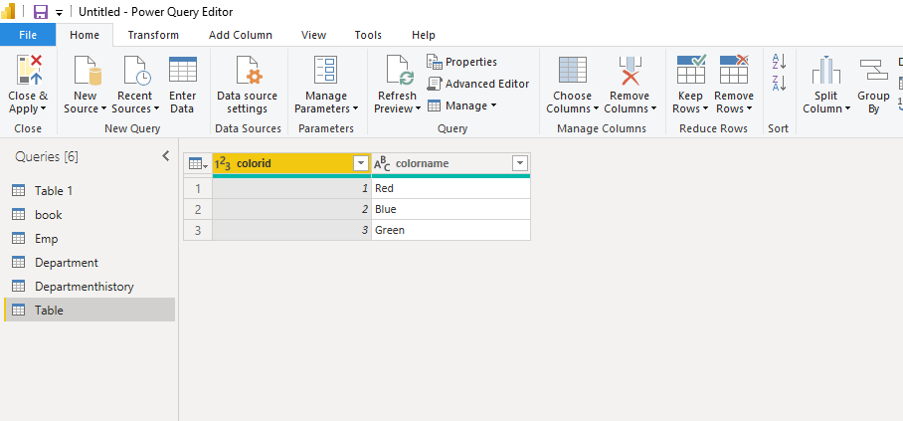

e. Reorder columns: colorname should come first followed by colored

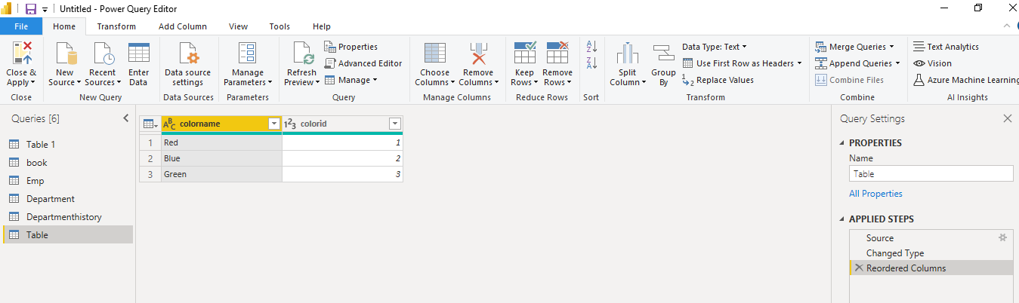

f. what is the purpose of chooose columns and go to column in query window

choose column: we can select the columns that need to be displayed.

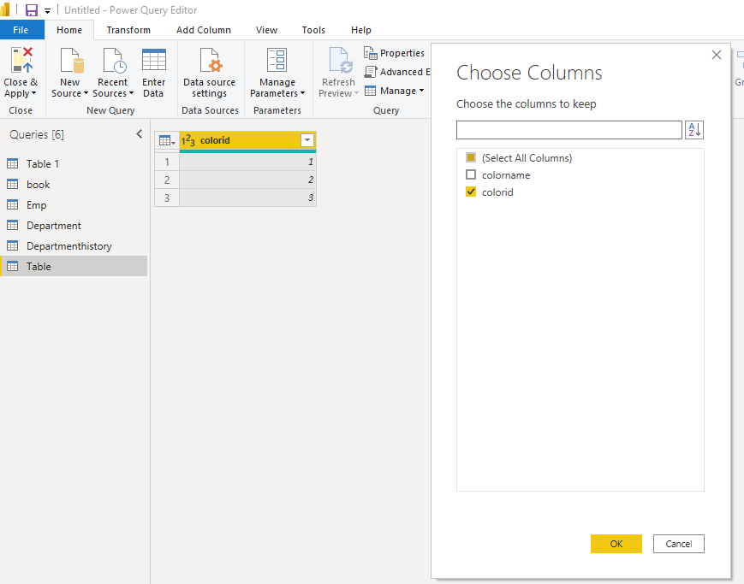

Go to Column: to quickly access the column

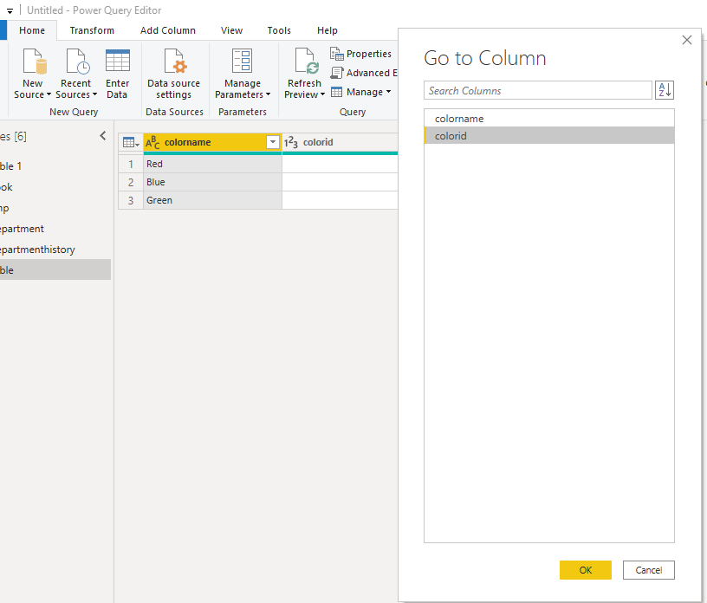

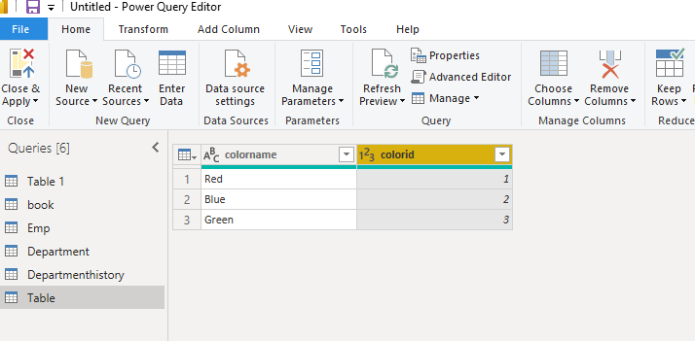

g. what is difference between use first row as headers and headers as first row

use first row as headers: To promote the first row to column headers.

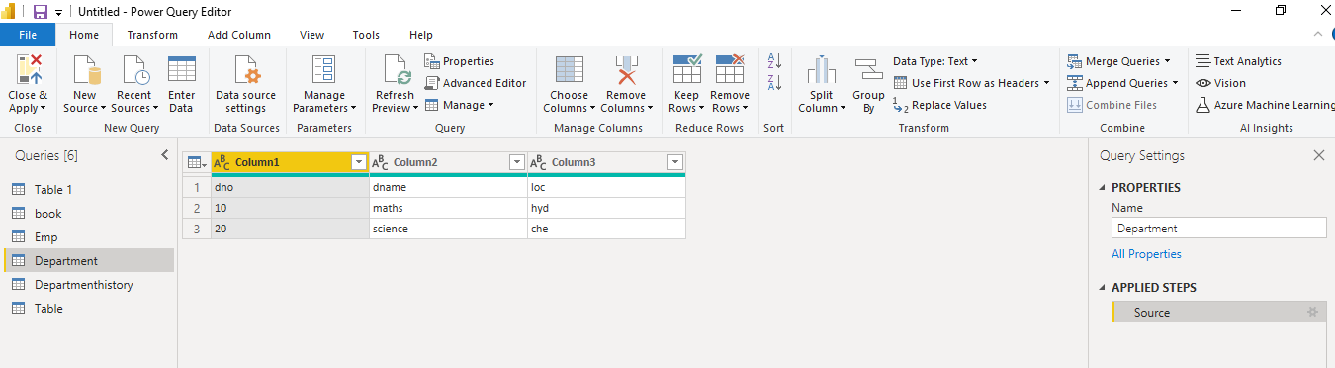

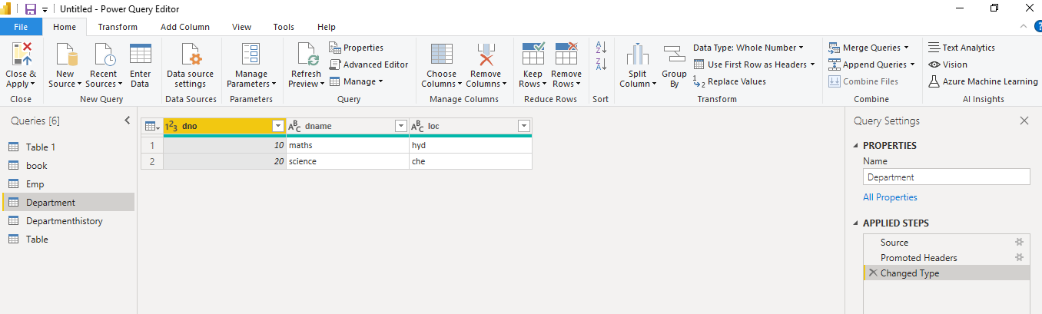

headers as first row: To demote column headers to the first row

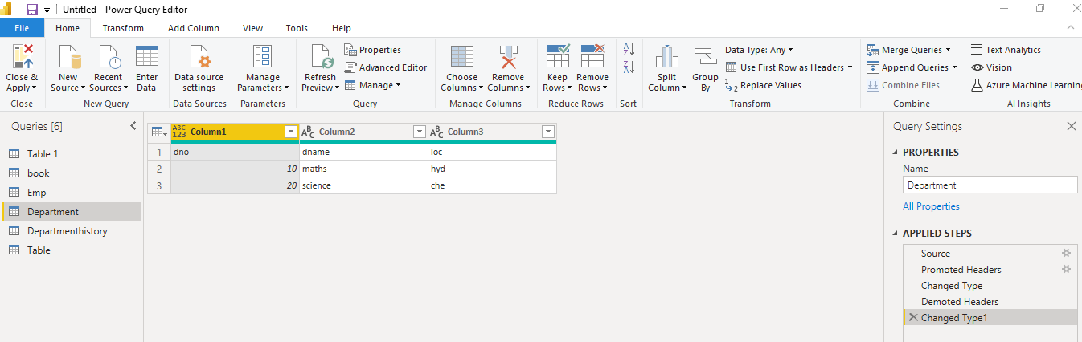

h. In querywindow for following data sort information first based on dno desc and with in each dno sal asc

emp.txt

dno,eno,sal

10,1,1000

10,2,2000

20,3,3000

20,4,4000

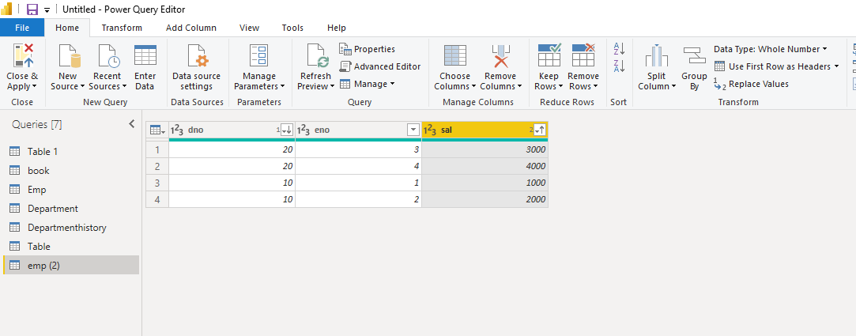

i.Pivot table and unpivot table

Unpivot below file data related to maths,physics and then pivot it back:

studentmarks

sname,maths,phyics

Hari,100,100

Kirshna,50,60

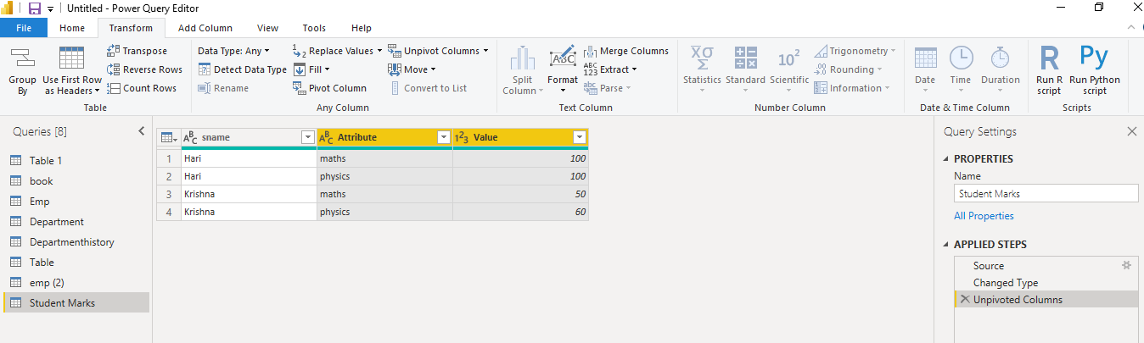

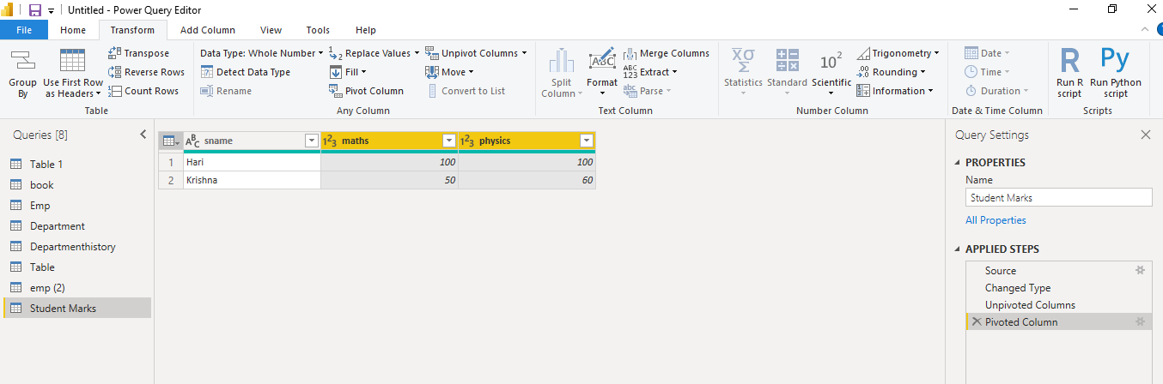

j. toprows, bottom rows ,range of rows, duplicates

emp.txt

dno,eno,sal

10,1,1000

10,2,2000

20,3,3000

20,4,3000

Show

Top 2 rows

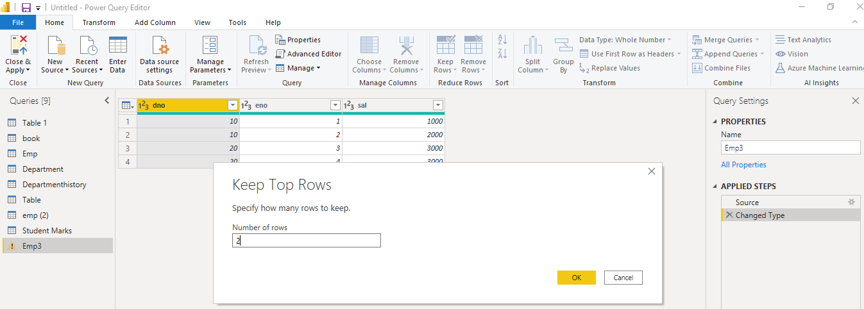

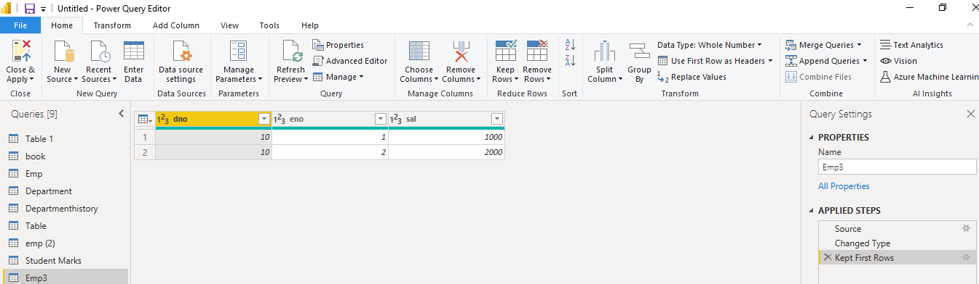

Bottom 1 row

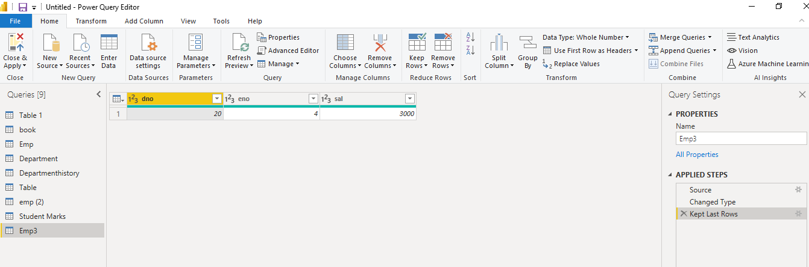

eno between 2 and 3

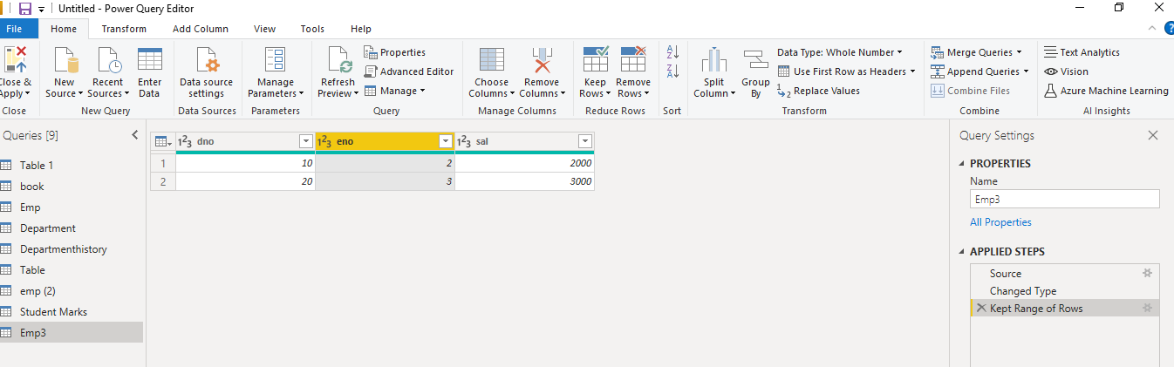

duplicate sal people

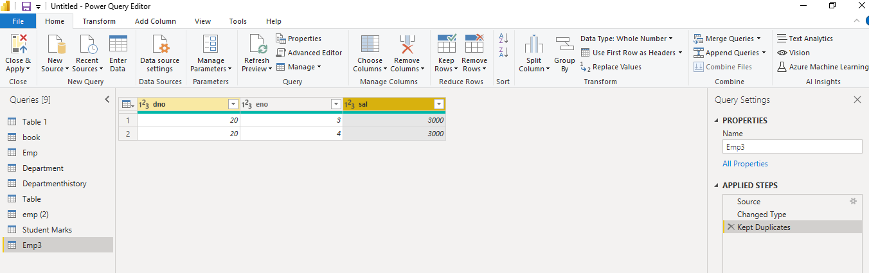

k. Mergequeries as new by Joining dept.txt and emp.txt on dno

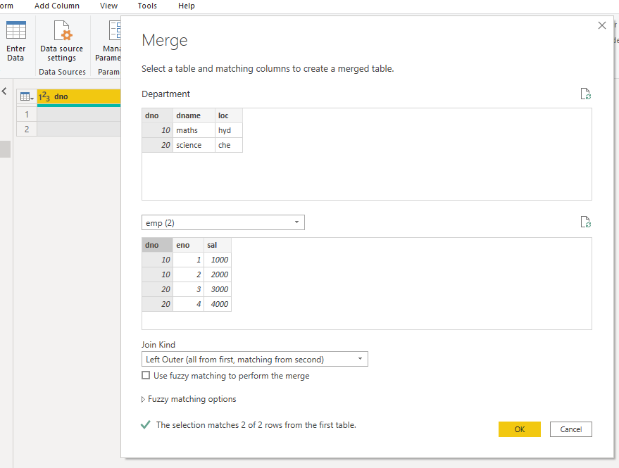

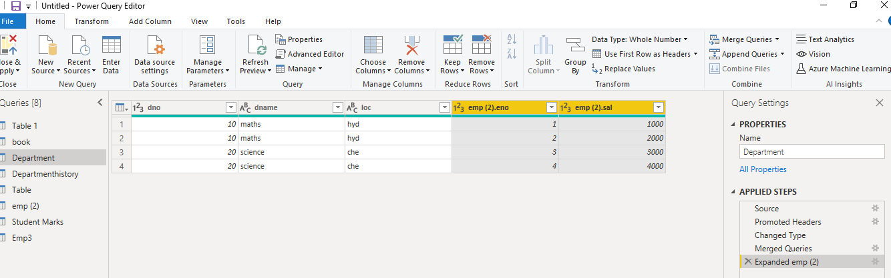

l. Split column

emp.txt file has below data:

eno,ename,sal

1,hari;krishna,$5000

2,sasi;kumar,$6000

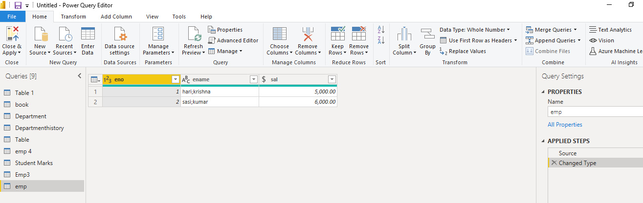

Split ename into fname and lname fields.

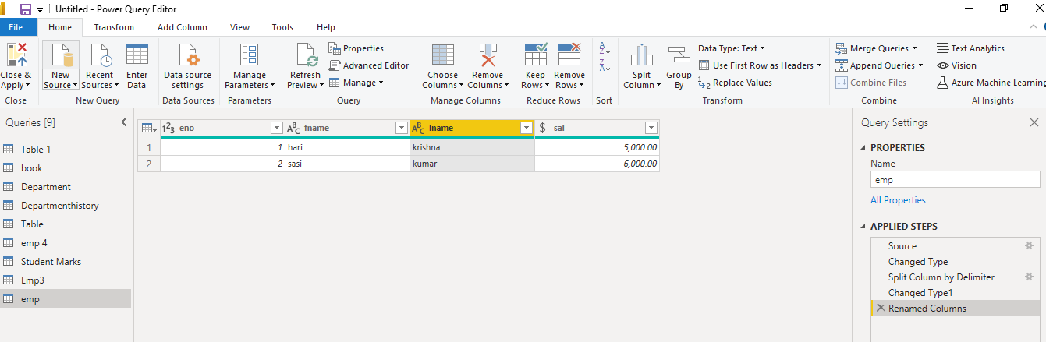

m.duplicate emp query, reference emp query and delete duplicated emp query

Duplicate query: it will be an exact copy of the first query, with all steps of it.

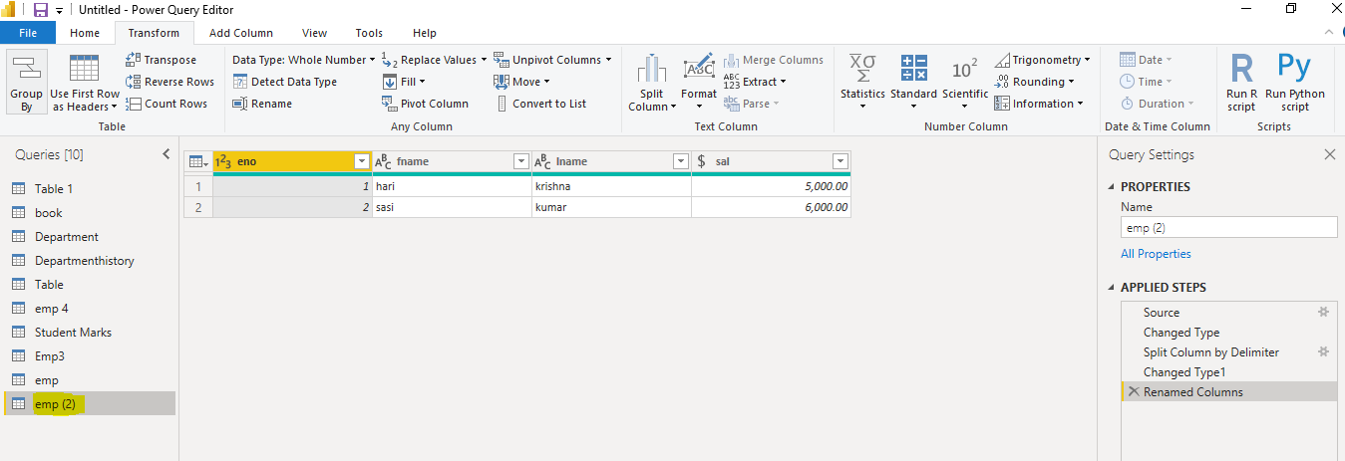

Referenced query: will not have the applied steps of the original query.

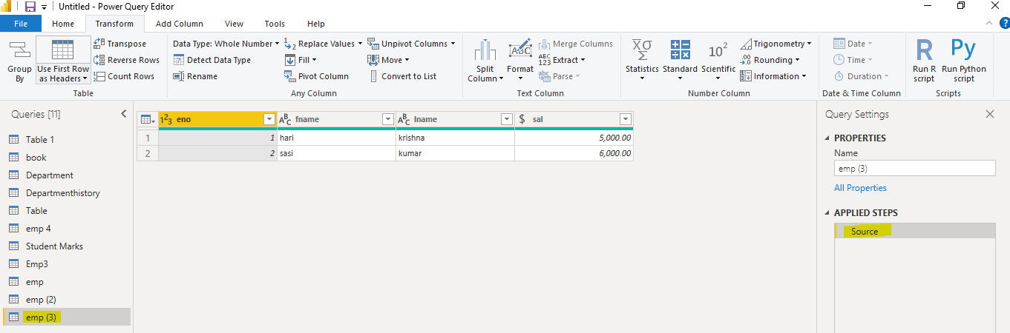

Delete duplicated query:

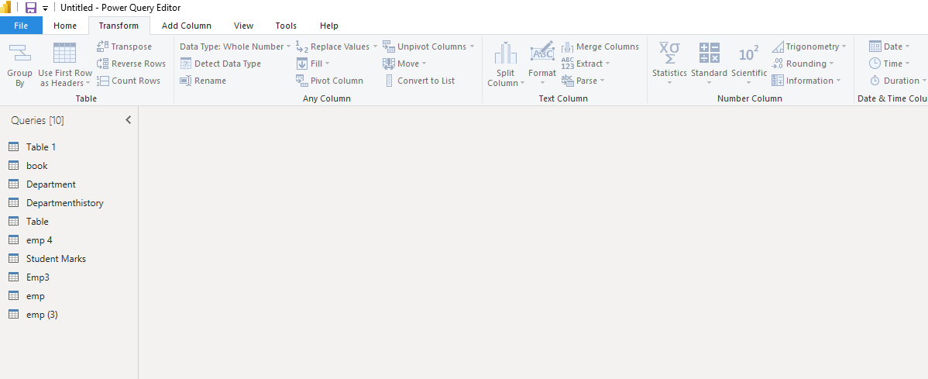

n. queries to seperate groups

emp query put in seperate group and dept query in seperate group

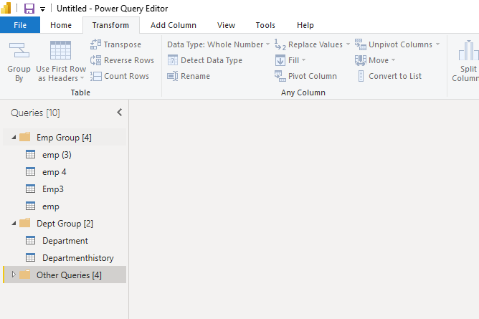

o. ungroup emp query

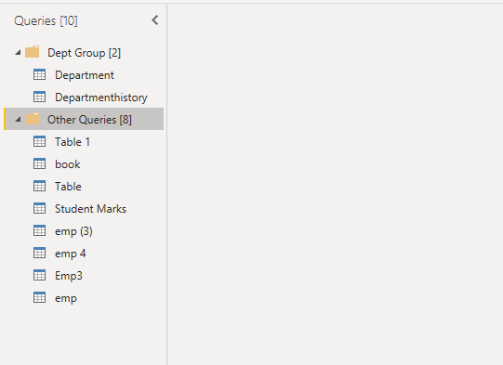

p. count rows in emp.txt file

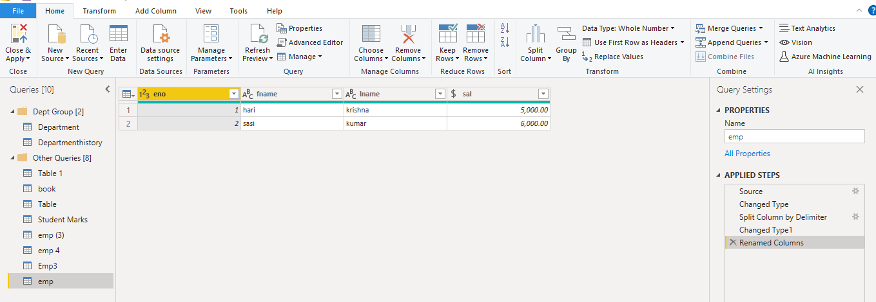

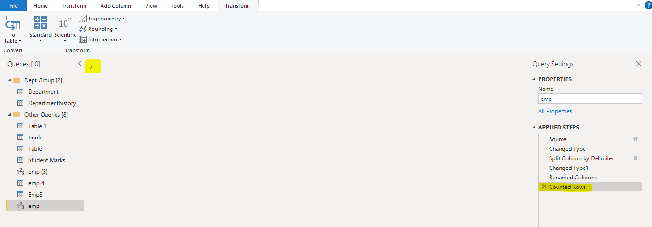

q. transpose category column of below file and then use firt row as headers to make category names as column names.

category.txt

categoryname,sales

c1,1000

c2,2000

c3,3000

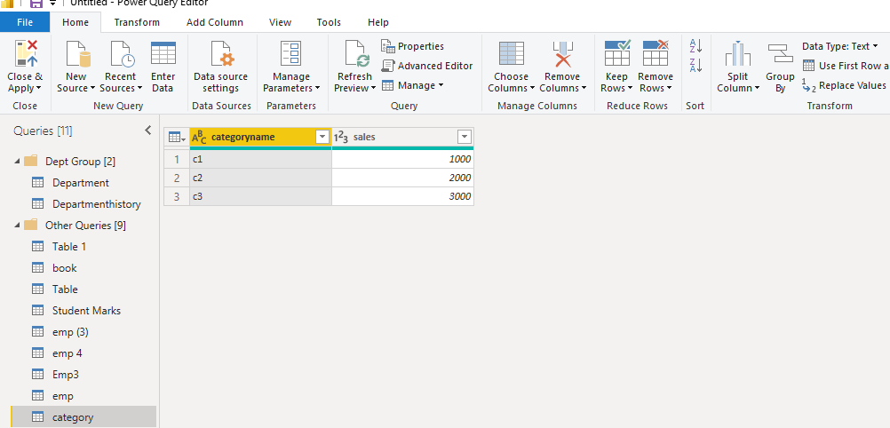

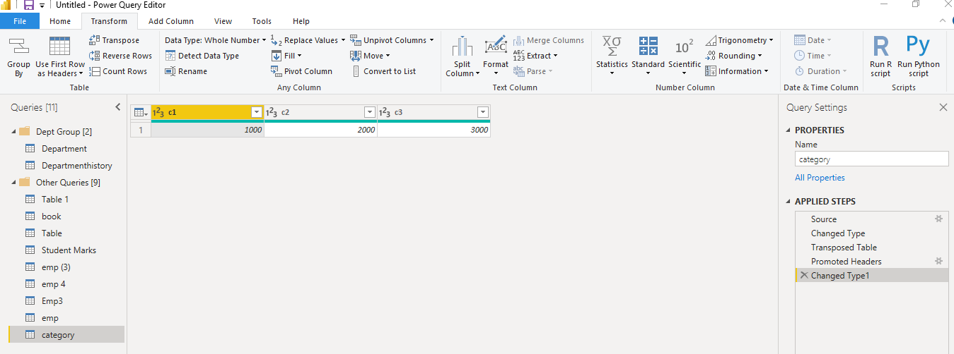

r. sort emp query on desc order of sal

